# Ideation Phase

|  |  |
| --- | --- |
| Date | 22 September 2022 |
| Team ID | PNT2022TMID25247 |
| Project Name | AI based discourse for Banking Industry |

**Empathy map:**

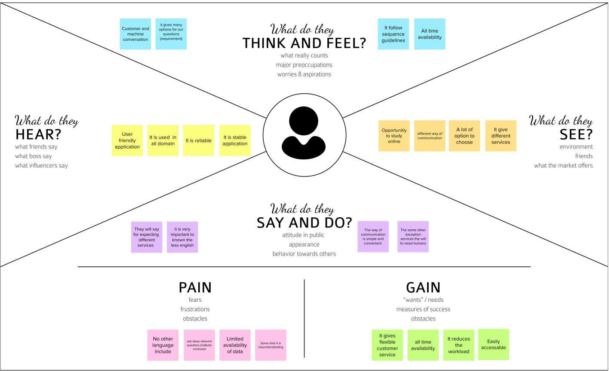

**Empathy map:**

https://app.mural.co/invitation/mural/aichatbotforbankingindustry3733/166141983 3787?sender=u18601c8be4ea48569db74064&key=3602040a-af15-4214-b32a- a64c11ae967a